**Project Plan**

**Team 13  
Cross Campus by XCampus**

|  |  |
| --- | --- |
| Primary Instructor | Anjana Shah |
| Team Member | Pavle Boraniev 100 972 255 |
| Team Member | Mark Gallant-Wheeler 100 800 311 |
| Team Member | Kazuma Sato 100 948 212 |

Document Revision History

|  |  |
| --- | --- |
| Revision # | Date |
| v0.1 | Friday, October 14, 2016 |
| v1.0 | Sunday, October 16, 2016 |
| V2.0 | Wednesday, April 12, 2016 |

**Table of Contents**

**1. Executive Summary** **2**

**2. Project Approvers, Reviews and Distribution List** **3**

**3. Scope** **4**

**4. Deliverables** **4**

**5. Assumptions** **5**

**6. Dependencies** **5**

**7. Risk Management** **5**

**8. Communication** **6**

**9. Task Listing (WBS- Work Breakdown Structure)** **7**

**10. Gantt Chart** **8**

**11. Milestones** **8**

**12. RAM – Responsibility Assignment Matrix** **9**

**13. Approval** **10**

# 1. Executive Summary

The following describes the project to be executed.

|  |  |
| --- | --- |
| Objective | Our research shows that while many post-secondary institutions provide services such as exam banks, and sponsored tutoring, very few approach the student need for these services from the standpoint of providing a “one stop shop” that can enforce uniform standards across their platform’s. As a consequence, the overall result is one that, often times, feels disjointed, and lacking in key areas. XCampus intends to address this fundamental lack.    XCampus will offer unified platform for tutoring, note sharing, and textbook classifieds to post-secondary students attending colleges and universities in Greater Toronto Area. Our primary strategy is to cater to a provisionally defined need for integrated solutions in the area of collaborative learning environments by conducting a campaign of direct marketing, with the use of social media alongside, to leverage the effectiveness. |
| Corporate Goals Addressed | Our initial directive will be to establish a base of operations within the various campuses of George Brown College. Upon successfully establishing this user base our plans are to expand further to other post-secondary institutions within the Greater Toronto Area, thus creating chapters within our organization that focus specifically on the needs of each institution respectively.    In all areas, we plan to establish accessibility to all services, student notes, tutoring services, and textbook classifieds. |
| Planned Start Date | Monday, January 9th 2017 |
| Planned End Date | Friday, April 19 2017 |

# 2. Project Approvers, Reviews and Distribution List

Approvers, reviewers and distribution list

|  |  |  |  |
| --- | --- | --- | --- |
| Project Role | Name | E-mail | Date |
| Team Member | Mark Gallant-Wheeler | mark.gallant@live.com | 10/14/2016 |
| Project Team Lead | Pavle Boraniev | pavle.boraniev@gmail.com | 10/14/2016 |
| Team Member | Kazuma Sato | kazuma.sato@georgebrown.ca | 10/16/2016 |

# 3. Scope

Define the sum total of all of its products and their requirements or features.

|  |  |
| --- | --- |
| In Scope | Out of Scope |
| Android Client | iOS |
| REST API | Enforcing Classifieds |
| Note and Classified Posting | Handling Payments |
| Advertising Space | Social Networking |
| Social Media Elements |  |
| Commenting |  |
| Rating |  |

# 4. Deliverables

This project will deliver the following.

|  |  |
| --- | --- |
| Deliverable | Description |
| Cross Campus Mobile App | We will create an android mobile app, utilizing our API to form the mobile portion of the CCCLE |
| XCampus API | This is the core of the CCCLE, providing functionality and resources for our front end implementations |
| Live Implementation | Our services will be implemented live |

# 5. Assumptions

1. In accessing XCampus services, it is assumed users have access to a computer, or Android device with internet access.
2. It is assumed that users are registered George Brown College students who have access to their George Brown e-mail accounts with the domain @georgebrown.ca.
3. It is assumed that users accessing services are registered in George Brown College courses.

# 6. Dependencies

1. The Cross Campus website and the Cross Campus mobile client app are both dependent on XCampus API.
2. XCampus API is dependent on a well structured database.
3. Cross Campus live implementation is dependent on a well written API pulling data from a functioning database, web app, and mobile app.
4. Cross Campus testing round One is dependent on the completion of the XCampus API.
5. Cross Campus testing round Two is dependent on the completion of the Cross Campus Web Client
6. Cross Campus testing round Three is dependent on the completion of the Cross Campus Mobile Client.

# 7. Risk Management

|  |  |  |  |
| --- | --- | --- | --- |
| Potential Risk | Severity (H/M/L) | Likelihood (H/M/L) | Management Strategy |
| Illegal / Contraband Content Being Uploaded | H | H | Monitoring and pre-approving all uploads before hosting them. Registering users with institutional emails. |
| Database breach/loss | H | L | Using an API to communicate with database. Making use of backups. |

# 

# 

# 8. Communication

**Reporting**

The following reports will be produced;

|  |  |  |
| --- | --- | --- |
| Report | Audience | Frequency |
| Software Requirements Analysis and Design | Program Coordinator | Once |
| Wireframes/  Prototype | Program Coordinator | Once |
| Project Status | Program Coordinator | Monthly |
| System Implantation | Program Coordinator | Bimonthly |
| Closure | Program Coordinator | Once |

**Meetings**

The following meetings will be established;

|  |  |  |  |
| --- | --- | --- | --- |
| Meeting | Purpose | Attendees | Frequency |
| Project Review | Status update on current tasks. | All team members | Weekly |
| Planning | Task and activity identification  Task distribution, assignment and scheduling | All team members | As-needed basis |
| Resolution | Resolve issues | All team members (Program Coordinator if required) | As-needed basis |

# 9. Task Listing (WBS- Work Breakdown Structure)

The following resource proposal template summarizes the resource hours committed to this project, upon final approval of this document.

|  |  |  |  |
| --- | --- | --- | --- |
| Reference | Tasks | Duration | Dependency |
| A | Entity Relationship Diagram | 1 Week |  |
| B | Implement Database In MySQL | 1 Week | A |
| C | Plan all data needed to be read and written to/from the database | 2 Weeks | A |
| D | Implement scripts to read from database. | 2 Weeks | C |
| E | Implement scripts to write to the database | 2 Weeks | C |
| F | Test all scripts to ensure the wanted data is read and written | 2 Weeks | D & E |
| G | Create wireframe for web application | 2 Weeks |  |
| H | Implement code based off wireframe for the front end web app1 | 3 Weeks | G |
| I | Test Web Application | 2 Weeks | H |
| J | Create wireframe for the Android application | 2 Weeks |  |
| K | Implement code based off wireframe for the front end Android app. | 3 Weeks | J |
| L | Test Android Application | 2-3 Weeks | L |

# 

# 

# 

# 10. Gantt Chart

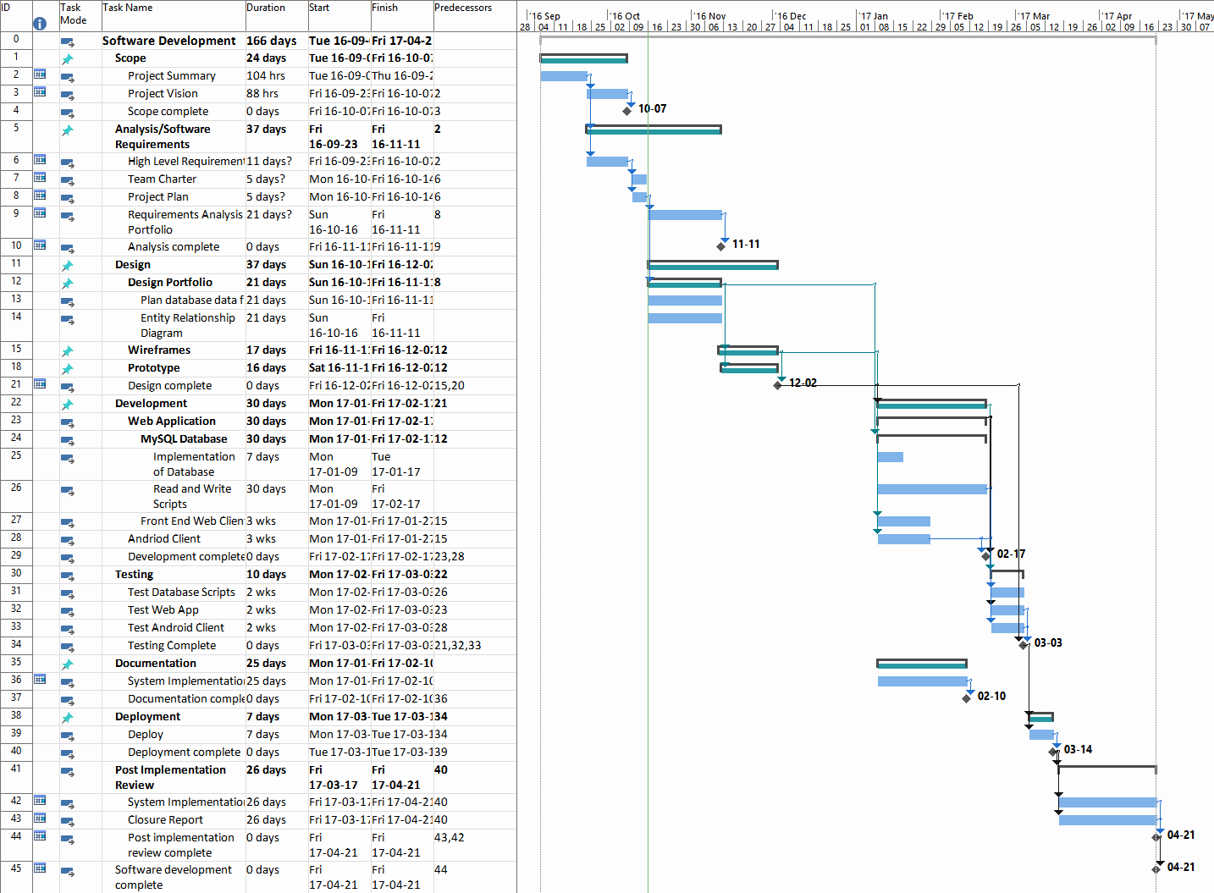

# 11. Milestones

|  |  |  |
| --- | --- | --- |
| Major Activity or Milestone | Estimated Milestone Target date | Owner/Reviewer Team Members |
| Project Presentation | October 18, 2016 | All Team Members |
| Requirements Analysis & Design | November 11, 2016 | All Team Members |
| Wireframes & Prototype | December 2 2016 | All Team Members |
| Development Completion | Mid February 2017 | All Team Members |
| Testing Completion | Early March 2017 | All Team Members |
| Deployment Completion | Late Match 2017 | All Team Members |
| Project Completion | April 31, 2017 | All Team Members |

# 12. RAM – Responsibility Assignment Matrix

|  |  |  |  |  |
| --- | --- | --- | --- | --- |
| **Project Team Responsibilities**  for Development, and Testing | | | | |
| **Project Name:** XCampus  **Project Team Lead:** Pavle Boraniev | | | | |
| Tasks | **Karim** | **Mark** | **Kazuma** | **Pavle** |
| Entity Relationship Diagram | P |  |  | S |
| Implement Database In MySQL |  | P | S |  |
| Plan all data needed to be read and written to/from the database | P |  | S | S |
| Implement scripts to read from database. | S | P |  |  |
| Implement scripts to write to the database |  |  | P | S |
| Test all scripts to ensure the wanted data is read and written | S |  | S | P |
| Create wireframe for web application |  | S | P |  |
| Implement code based off wireframe for the front end web app | P | S | S |  |
| Test Web Application |  | P | S | S |
| Create wireframe for the Android application |  | P | S |  |
| Implement code based off wireframe for the front end Android app. |  | S | S | P |
| Test Android Application | S | S | P |  |
|  | P = Primary S = Secondary | | | |

# 13. Approval

The signatures below indicate their approval of the contents of this document.

|  |  |  |  |
| --- | --- | --- | --- |
| Project Role | Name | Signature | Date |
|  | Mark Gallant-Wheeler | x | 10/16/2016 |
|  | Pavle Boraniev | x | 10/16/2016 |
|  | Kazuma Sato | x | 10/16/2016 |
|  | Karim Boucher | x | 10/16/2016 |